**Create a simple cloud software application for Payroll Processing System using any Cloud Service Provider to demonstrate SaaS include the necessary fields such as Name of the employee, experience in present org , over all experience, basic pay, HRA, DA, TA, net pay, gross pay etc.**

**AIM:**

Create a simple cloud software application for Property Buying & Rental process (In Chennai city) using any Cloud Service Provider

**PROCEDURE:**

**STEP 1:**

Open browser and get into zoho ceator. Then sign in and click “Create application”. Below given screenshot will appear, hear type the application name of your Aim.

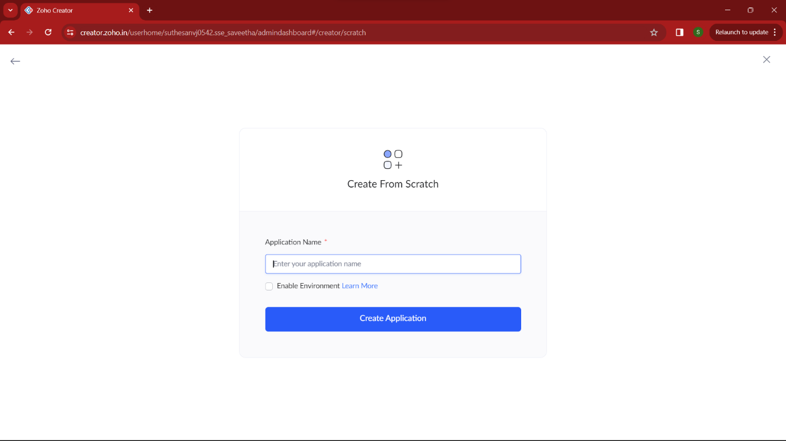

**STEP 2:**

Then select “start from scratch” option and select the proper component from the 4 components listed. For my application I just selected “forms” for the login credentials.

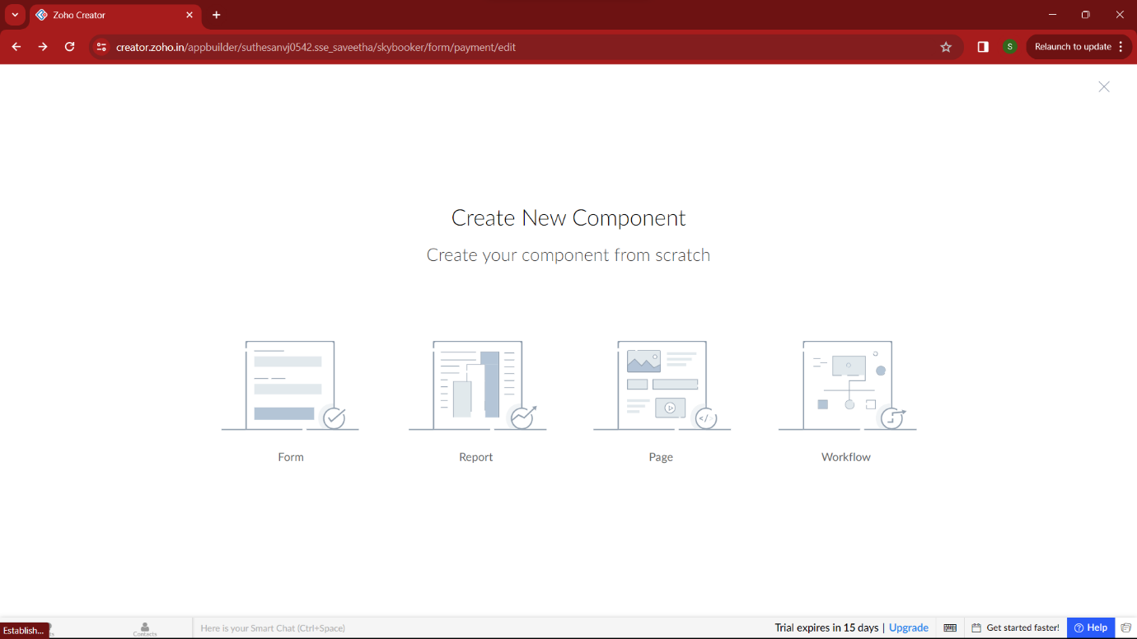

**STEP 3:**

In forms, below given options will be given. From here we can get sample templates of our requirements, otherwise we can import already saved schema for our application. I just selected “ from scratch” option for my application.

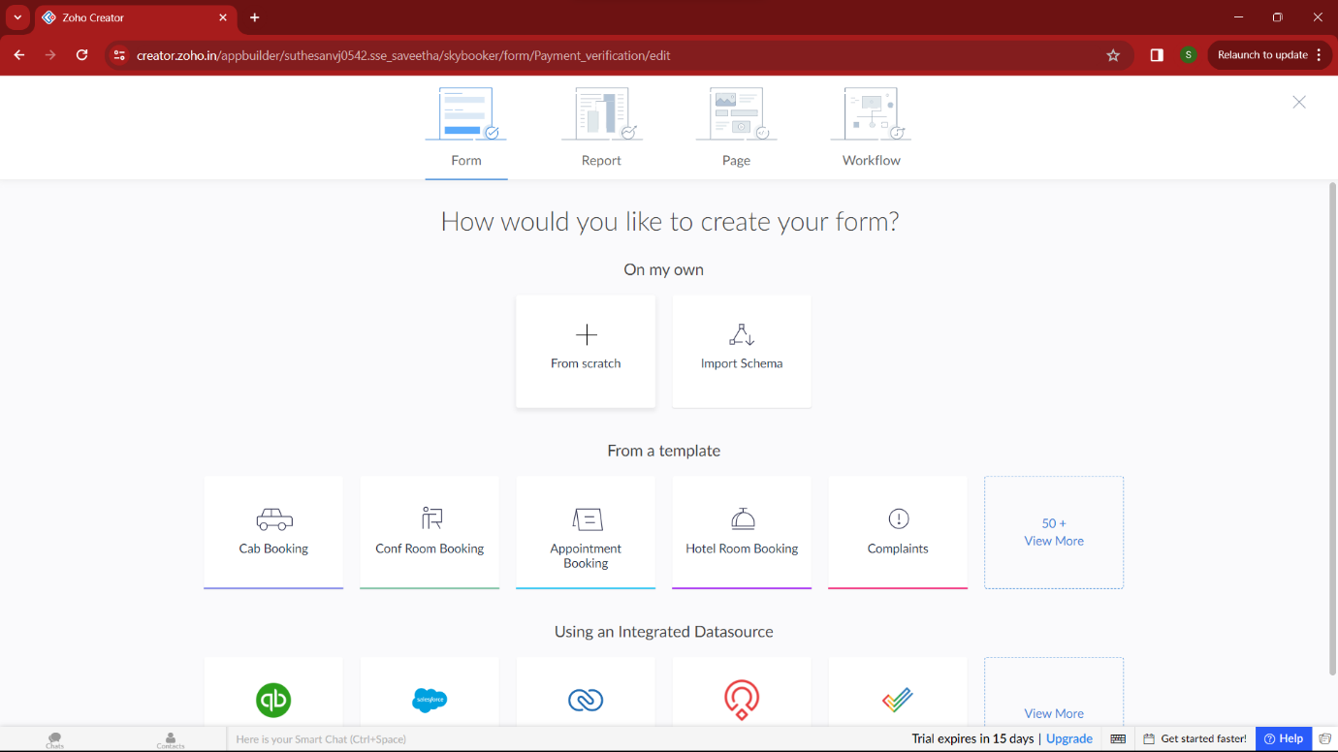

**STEP 4:**

Then provide an appropriate name for our application in the name form which shown below. I gave “WageWise” for my “payroll processing system”

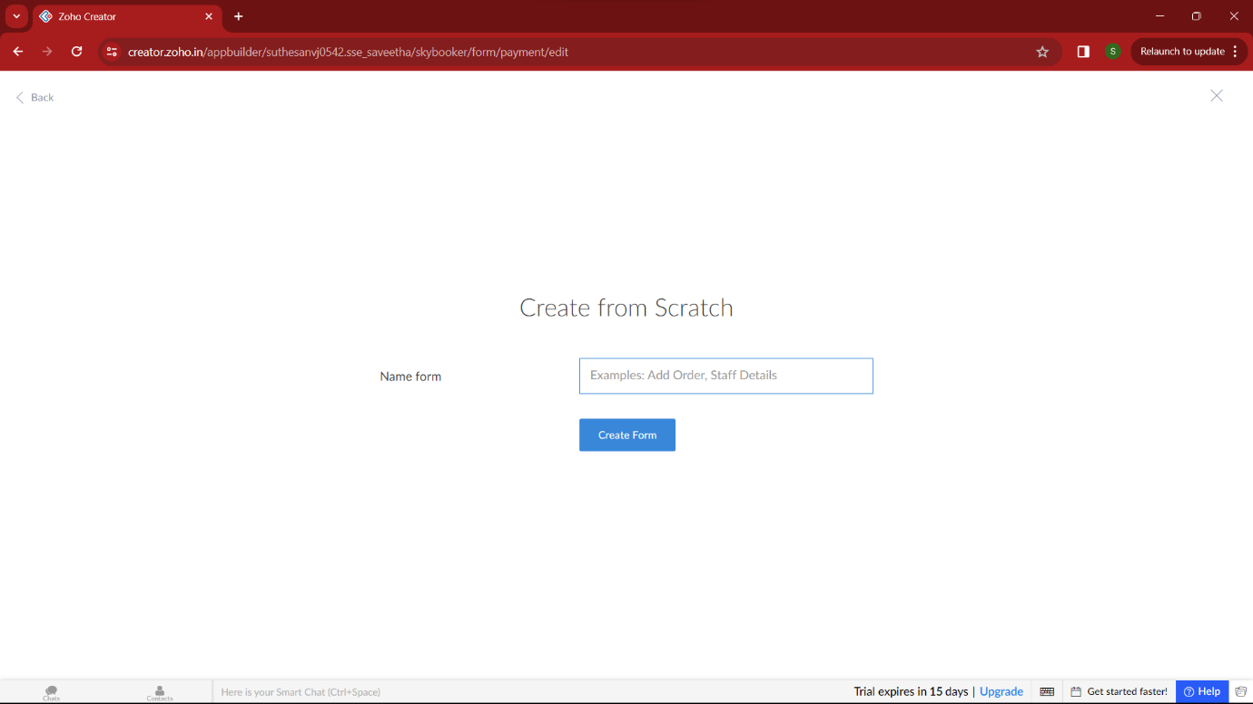

**STEP 5:**

by clicking “+” symbol shown in the picture given below, we can add number of forms in our application. Firstly I placed login form in my application with the essential credent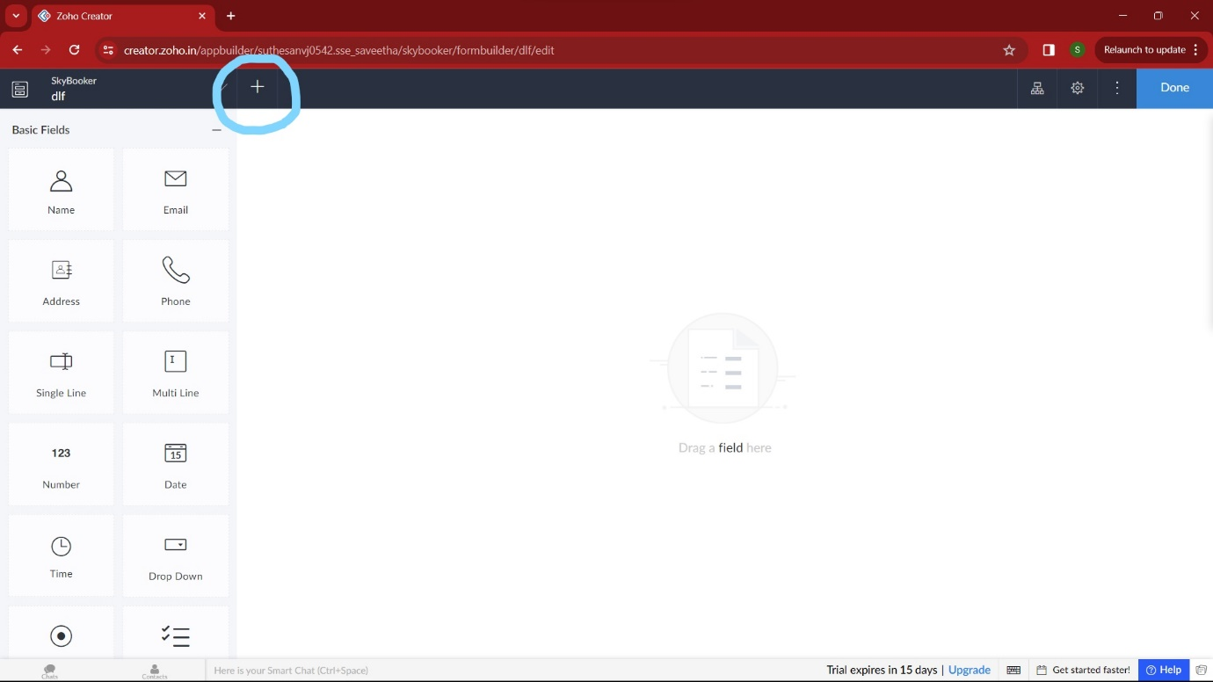

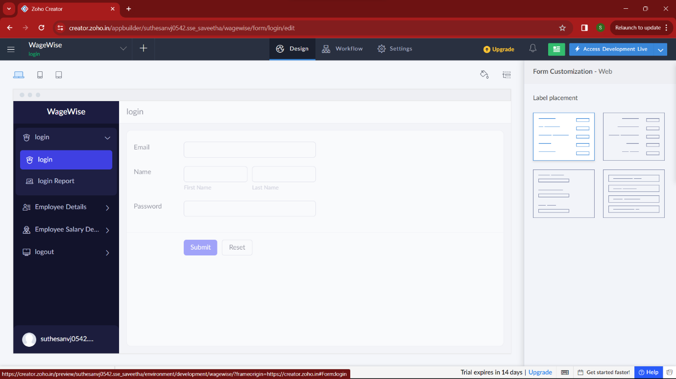

**STEP 6:**

Then I added another form namely “employee detail”. It gets all the details of the employee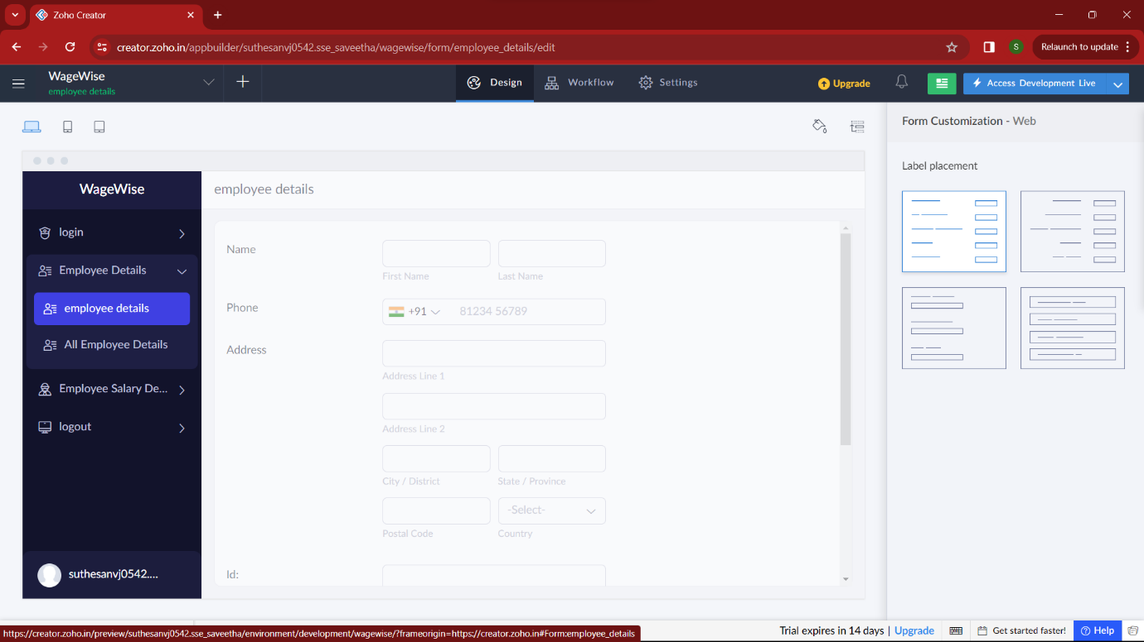

**STEP 7:**

Then I added another form namely “employee salary detail” which shows the salary , attendance, id, taxes and every details of the employee salary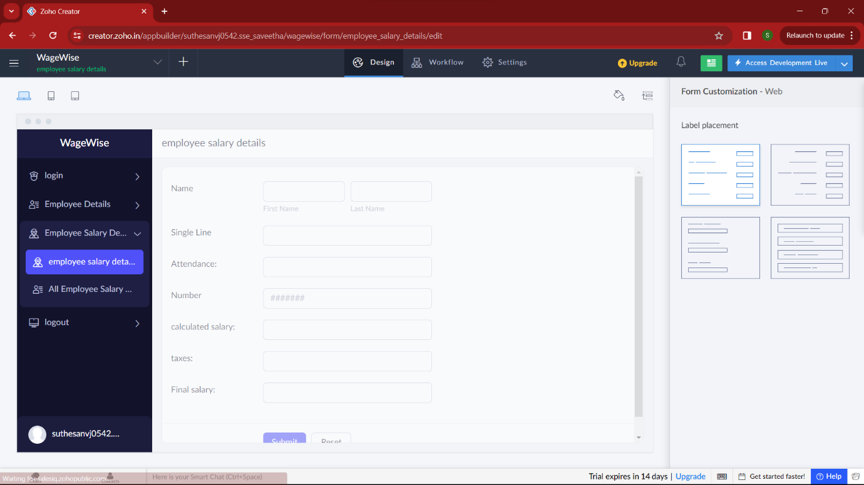

**STEP 8:**

Then in the next form I added “logout”. Here the owner/user can logout after accessing the salary detail.